Name : Sakthi Manoj R Reg No : 192324236
PROGRAM 20
Create a Multiple Regression Model Using the ChickWeight Dataset
Aim:
To predict chick weight using Time and Diet as predictors and calculate the model's mean squared error.
Procedure:
Step 1: Open RStudio or the R console on your computer.
Step 2: Load the built-in ChickWeight dataset.
Step 3: Use lm() to create a regression model with weight as the response and Time and Diet as predictors.
Step 4: Use predict() to calculate predicted weight values from the fitted model.
Step 5: Calculate mean squared error (MSE) by averaging the squared differences between actual and predicted weights.
Step 6: Print the MSE to evaluate the model's prediction error.
Output :
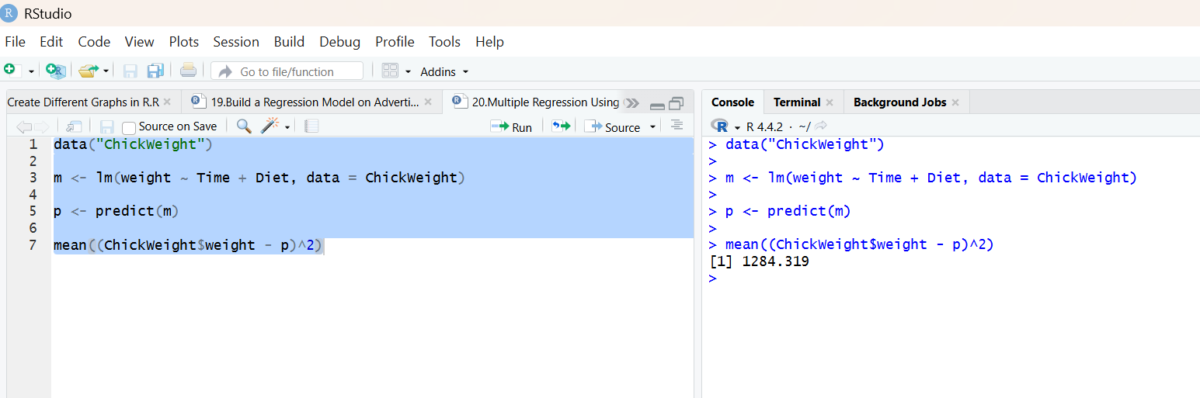
Result:
Hence the output is verified successfully.

